Familiar Foundations
Introducing Pitch-Class Theory Through Use of Familiar Materials in Tonal Music
Dr. Zachary C. Daniels
2026

Familiar Foundations
Introducing Pitch-Class through Use of Familiar Materials in Tonal Music
  - Dr. Zachary C. Daniels, DMA
Adjunct Professor of Music, Oklahoma City University

Introduction
One of the most anxiety-inducing topics for our students, and even some instructors, is pitch-class theory. For many programs, the topic is all but unavoidable on the path to graduation for at least some of our students. We introduce them to the seemingly foreign language of integer notation in the context of analyzing music that pushes the boundaries of what they perceive as music. We are expecting our students to embrace atonality while also embracing that tried-and-true diatonic analysis is no longer relevant to the music we are observing in class, at least for a while.
Much of the foundational literature on post-tonal theory are primarily concerned with the internal logic of the system and its application to post-tonal repertories rather than the process by which students first encounter the concepts. In classroom practice, the result is often that pitch-class theory is introduced at precisely the moment students are also asked to contend with unfamiliar repertory, and often strange notation. The challenge is not that existing presentations are wrong, but rather the route from tonality to post-tonal analysis is pedagogically underdesigned.

The Existing Pedagogy
When discussing pitch-class theory, there is already an established body of critical texts on the subject from the likes of Forte, Morris, Straus, and others. Leading textbooks such as Joseph Straus’ Introduction to Post-Tonal Theory serve as a great resource for graduate students, in particular, as they learn these tools of pitch-class theory alongside the music they are designed to analyze. Leading comprehensive music theory textbooks with dedicated post-tonal music chapters and units also fall into this pattern, such as in the Clendenning and Marvin Musician’s Guide to Theory and Analysis or the Kostka Tonal Harmony. These leading textbooks all finish up extended chromaticism and quickly pivot to the breaking point in which tonality is shattered and the need arises for a new method by which to analyze and compose this strangely alien-sounding music.
We are giving our students unfamiliar music, and an unfamiliar set of tools to work with. Post-tonal music is not something most students are exposed to until collegiate study, and even so it often happens in relatively sparing amounts. Integer notation and pitch-class theory are immediately anxiety-inducing, particularly for those students who may have struggled in traditional math courses. This creates an unnecessarily complex set of barriers for our students which we are forced to rethink when we consider the removal of barriers wherever possible.

Theoretical Framework
Research in learning theory offers a strong rationale for introducing concepts with familiar musical materials. Ausubel’s model of meaningful learning emphasizes that new knowledge is retained more effectively when it is consciously connected to what the learner already knows, rather than memorized in isolation. Related work on schema formation suggests that students understand new information better by attaching it to preexisting mental frameworks. Scaffolded instruction in the tradition of Bruner and Vygotsky supports the gradual movement from the known to the unknown. In music pedagogy, these principles are especially relevant because students do not encounter analytical concepts in a vacuum; they encounter them through repertories, stylistic expectations, and prior classroom experiences that shape comprehension.
When students revisit a Bach chorale, a Mozart sonata, or a Chopin prelude they have already analyzed, they are not starting from nothing. This reduces the double burden of unfamiliar repertoire and unfamiliar method, lowers cognitive overload, and makes pitch-class theory feel less like a rupture in the curriculum than an expansion of the tools available to our students. On this basis, the Familiar Foundations approach proposes that students first learn to hear, label, and manipulate pitch-class relationships within tonal contexts before extending those same analytical habits into fully post-tonal repertories.
Pedagogy in music theory already benefits from utilizing familiar music and recontextualizing it throughout curriculums, such as marking instances of chromaticism in Theory I before labelling it and analyzing its function in Theory II. While there is ample debate around the benefits of recycling examples with added context balanced with exposure to new music, it is my experience that more advanced topics often necessitate safer, more familiar musical examples. Each program will have their own familiar materials and music, which might come from anywhere in your own pedagogy. By utilizing familiar music, we aim to bridge the gap between the familiar tonal music, and atonal music’s analytical tools.

Methodology

Institutional Context
At Oklahoma City University, the Wanda L. Bass School of Music has around 300 undergraduate students, the majority of whom are musical theatre majors, all of which are required to complete our core music theory sequence. This includes Music Theory and Aural Skills 1, 2, and 3, followed by our reimagined fourth semester of music theory which typically consists of two topics courses of their choosing. Some majors are required to complete additional topics courses such as counterpoint, but our typical offerings have ranged from pop music analysis to film music analysis, art song, and, of course, Music Since 1900.

Development of the Method
Familiar Foundations emerged in 2023, as I was assigned to teach Music Since 1900 the following spring. My goal with pitch-class theory and atonality was to simplify the transition by applying pitch-class analysis to a Bach chorale in a way roughly analogous to traditional roman numeral analysis. It was my hope that this would provide a more familiar starting point for my students as they began their journey into pitch-class theory. This would, in turn, help students transition more fully to musical analysis in post-tonal contexts. The result was a clear and effective entry point that also cast inversions and secondary sonorities in a new analytical light.
Figure 1 Bach chorale BWV 112.5 Analyzed Using Pitch-Class
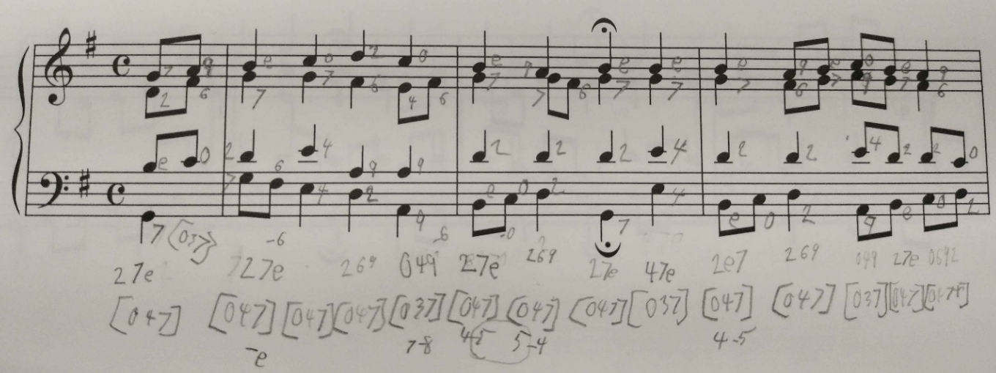
I shared this developing approach with a small number of colleagues, several of whom enthusiastically adapted it to their own classrooms and curricula with encouraging early results. As of this writing, the method has yet to be implemented in a graduate-level course setting, though the method may prove useful for remedial or review-oriented coursework that some of our graduate students take.

Materials
While the concept of familiar music may vary by institution, the list below may serve as a useful starting point for considering what materials might work well in a typical undergraduate theory curriculum:
J. S. Bach chorales BWV 269 and BWV 112.5
Although I chose to include these two chorales in particular, any Bach chorale could serve this purpose effectively.
W. A. Mozart, Sonata in C Major, K. 545, first movement
This is another recurring work in my pedagogy. Students who study with me encounter it at different analytical levels, first for phrase structure and later for chromatic elements.
Frédéric Chopin, Prelude in C Minor, Op. 28, No. 20
This is also a recurring work in my pedagogy. Students in our Theory 3 courses have previously analyzed it while studying chromaticism.
My materials also include a student-built “recipe book” of commonly used chords presented through pitch-class analysis. The chart is easy enough to understand; chord name and quality in the far-left column, followed by space for students to supply the roman numeral as review, write the corresponding pitch-class set, and then determine the normal order and prime form. An optional activity based on this sheet asks students to compare the pitch-class notation of major and minor triads, and to note that the dominant seventh and the German augmented sixth share the same prime form.
Figure 2 Recipe Book Excerpt
Chord Type | RN | Pitch Classes | Normal Order | Prime Form
Dominant Seventh | V7 | 257e | 047t | 0258^

Instruction
To help students understand why we briefly return to tonal music before moving into post-tonal repertoire, I began by showing a representative excerpt of atonal repertoire on the board. For this purpose, I used Schoenberg’s Op. 11, No. 1.
Figure 3 Schoenberg, Opus 11 no. 1
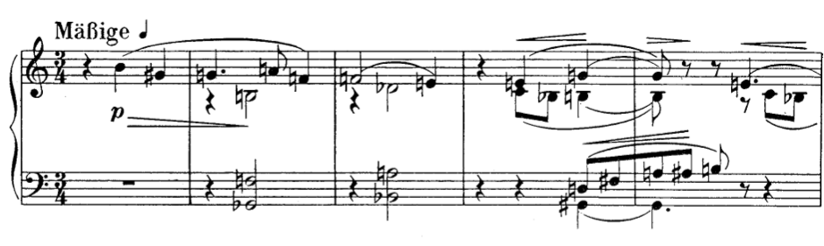
After introducing the problems diatonic analysis would have, I pivoted to a familiar piece of music that my students are familiar with from the common practice period. For this I selected Bach BWV 269, as students who had myself for Theory II would have analyzed this already and it is accessible enough that those taught by others on our theory faculty would have no problems analyzing it using diatonic RNs. I then explained that we will begin analyzing this short, tonal piece of repertoire using a new set of tools called pitch-class theory.
I begin with pitch-class identification, introducing the vocabulary and tools, and later the concepts behind pitch-class theory by drawing connections to familiar musical elements such as major and minor triads, the dominant seventh, and other sonorities relevant to the assigned excerpt, while students begin to fill in their Recipe Book.
Figure 4 Bach, BWV 269 (pitch-class sets identified)
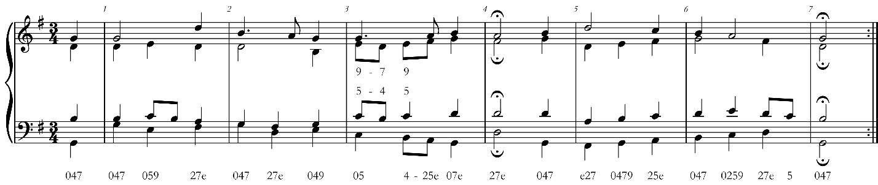

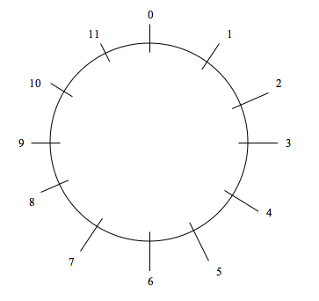
After this introduction to pitch-class sets and their relation to major and minor triads, inversions, and other chords present in the excerpt, I move to the operations of transposition and inversion with the goal of helping students determine normal order and prime form for each set. I illustrate these procedures with clock-face diagrams such as the one shown here, alongside ordered sets and numerically based methods. We then apply this understanding of prime form to the excerpt and discover, among other things, that major and minor triads share the same prime form.
Figure 5 Clock Face
After this introduction to the core tools of pitch-class theory, the students are assigned a separate familiar piece of repertoire as homework. On day two, the class begins applying these materials to atonal music, with particular attention to identifying and grouping pitch classes.

Results

My Classroom Results
For my own courses, the introduction of pitch-class theory showed promising initial results. I noted an increase in student retention of set identification and labelling as well as transformational operations, particularly remapping sets using clock face diagrams. These numbers are based on assessments, with the same questions given to each group of students. In discussions with students from sections both with and without the familiar foundations method it was found that the removal of the double barrier of pitch-class theory in tandem with atonal music was a helpful way to ease them into atonal music. The most impressive results from a curricular standpoint, however, are in class-time savings of as much as a 50% reduction in instruction time needed. With today’s rapidly growing pedagogical challenges, that time savings is immensely valuable.

Other Implementations
Dr. Kate Sekula at Oklahoma City University introduced her own permutation of the Familiar Foundations method in Spring of 2026. This lesson plan is not included in this paper for the sake of brevity, but the major divergence was in her initial presentation of the problem. Instead of showing the students an atonal excerpt as I did, she approached it as a class activity wherein the students were alien creatures with no understanding of music and tasked with finding a rational explanation for notes on the page of a Bach chorale. With some guidance, students discovered the usefulness of numbering their pitches 1-12 beginning on their Do (D). She then showed them why 0 must be included, and that while their assignment of 1 (now 0) to Do was perfectly fine – there are many advantages to standardizing around a singular pitch of C as 0. Aside from this introduction, much of the other content and delivery remained the same, and even her transition to atonal music afterwards met with much the same revelations as with my own classes.

Student Response
There is no longer a sense of overwhelming dread when talking about pitch-class theory, with students instead rising to the challenge and demonstrating a newfound curiosity. Many students are going so far as to enthusiastically inquire about what an application of said methods might look like ahead of atonal music’s full introduction. This is a recognizable improvement over previous student misconceptions that I welcome as a very positive change. I hope to see this change in approach help other students in the future as well.

Discussion
The results of the Familiar Foundations approach support the initial premise of this paper: students learn pitch-class theory more effectively when the new analytical concepts are introduced through musical materials they already know. Demonstrable gains in retention, stronger command of transformational operations, and a reduction in required instructional time all point toward a more efficient bridge between tonal fluency and post-tonal analysis. These findings suggest that students benefit when new analytical language is attached to preexisting musical schemas rather than presented alongside unfamiliar repertory. Instead of asking students to process a new repertoire, a new vocabulary, and a new method at the same moment, this approach narrows the task and allows them to focus on the analytical concepts themselves in a familiar musical context which also narrows the focus during the introduction of post-tonal analytical techniques. The result is not a simplification of pitch-class theory so much as a more intentional sequencing of its introduction.
Pedagogically, the significance of these findings lies in the lowering of cognitive load and affective barriers at the first point of contact with post-tonal analysis. Students are not merely remembering labels more successfully; they are also approaching the material with greater confidence and curiosity. A topic once framed as one of the most difficult in the undergraduate theory sequence becomes instead a continuation of their developing analytical habits. This reframing encourages a meaningful transfer of skills wherein students begin to see that pitch-class theory is not only a tool for highly abstract atonal passages, but also another method of revealing structural relationships in any piece of music.
The observations presented here are drawn from a relatively small number of classes, sections, and institutional contexts. Additionally, much of the evidence remains instructor-reported rather than gathered through a larger formal study. Familiarity itself is also variable: a Bach chorale or Mozart sonata may function as familiar repertoire in one curriculum but not in another, meaning that the success of this method depends in part on thoughtful local adaptation. Initial findings align well with meaningful learning theory, schema-based learning, and scaffolded instruction by demonstrating that students appear to understand pitch-class concepts more readily when those concepts are anchored in previously mastered material. Familiar Foundations expands upon existing literature by establishing the need for a more pedagogically deliberate pathway into pitch-class theory at the undergraduate level.

Implications and Recommendations
Instructors adopting Familiar Foundations should begin by selecting repertoire that students have already encountered analytically and aurally in earlier coursework. The best examples would be works that already carry pedagogical familiarity within a particular curriculum.
Regarding curriculum design, Familiar Foundations seems to suggest that pitch-class theory need not appear only as a late-semester rupture from tonal analysis. Instead, it is possible that programs may benefit from treating it as an extension of earlier theory work, with brief preparatory encounters before the post-tonal unit begins. Integration could take many forms, such as short comparative activities in a chromatic harmony unit, or even to the foundational concepts of tonal music theory. Such methods are already lightly touched upon when introducing the interval, where counting the half-steps between two pitches (or even a third) is seen as a viable pedagogical approach by many.
Future inquiry might also explore whether the same familiar-to-unfamiliar pathway could strengthen the teaching of other topics across the theory curriculum. If so, the implications of this project may extend beyond pitch-class pedagogy and point toward a larger principle: students often encounter advanced theory most successfully when new abstractions naturally grow out of and expand upon previously secured musical understanding.

Conclusion
Pitch-class theory remains an essential part of many music programs, but its importance does not require that it be introduced in its most intimidating form. The Familiar Foundations approach argues instead for a pedagogical sequence in which students first encounter pitch-class concepts through tonal materials they already know, allowing them to connect new analytical tools to established musical understanding. The evidence presented here suggests that this approach can improve retention, strengthen student confidence, and reduce the amount of time required to move into post-tonal analysis without weakening the rigor of the material. More broadly, it reflects a simple but important pedagogical principle: students learn difficult ideas more meaningfully when instruction is rooted in what is already familiar. In that sense, Familiar Foundations is not only a strategy for teaching pitch-class theory, but also a model for how music theory pedagogy might continue to evolve in response to the needs of students in the 21st century.

Bibliography
Ausubel, David P. “A Subsumption Theory of Meaningful Verbal Learning and Retention.” The Journal of General Psychology 66, no. 2 (1962): 213–224. doi:10.1080/00221309.1962.9711837.
Bartlett, F. C. Remembering: A Study in Experimental and Social Psychology. Cambridge: Cambridge University Press, 1932.
Bozzato, Paolo, Erica Corradi, Marco Crudo, and Iris Pelizzoni. “The Perception of Educational Barriers, Their Sociodemographic Correlates, and Their Relationship with Future Orientation in Italian Adolescents.” Education Sciences 15, no. 9 (2025): 1208. doi:10.3390/educsci15091208.
Clendinning, Jane Piper., and Elizabeth West. Marvin. The Musician’s Guide to Theory and Analysis. W. W. Norton & Company, Inc., 2021.
Kostka, Stefan M., and Byron. Almén. Tonal Harmony with an Introduction to Post-Tonal Music. McGraw Hill LLC, 2024.
Rogers, Michael R., Teaching Approaches in Music Theory : An Overview of Pedagogical Philosophies. Southern Illinois University Press, 2004.
Wood, David, Jerome S. Bruner, and Gail Ross. “The Role of Tutoring in Problem Solving.” Journal of Child Psychology and Psychiatry 17, no. 2 (1976): 89–100. doi:10.1111/j.1469-7610.1976.tb00381.x.

Straus, Introduction to Post-Tonal Theory
Clendinning, Jane Piper., and Elizabeth West. Marvin. The Musician’s Guide to Theory and Analysis. W. W. Norton & Company, Inc., 2021.
Kostka, Stefan M. .., and Byron. Almén. Tonal Harmony with an Introduction to Post-Tonal Music. McGraw Hill LLC, 2024.
D. Ausubel, “A Subsumption Theory of Meaningful Verbal Learning and Retention”, Journal of General Psychology, Vol. 66, 1962, 213-214, doi:10.1080/00221309.1962.9711837.
F. C. Bartlett, Remembering: A Study in Experimental and Social Psychology (Cambridge: Cambridge University Press, 1932).
D. Wood, J. S. Bruner, and G. Ross, “The Role of Tutoring in Problem Solving”, Journal of Child Psychology and Psychiatry, Vol. 17, 1976, 89-100, doi:10.1111/j.1469-7610.1976.tb00381.x.
This is something I have successfully implemented in a Theory III course when discussing enharmonicism and the Ger+6 as an enharmonic modulation.
Optionally, an instructor could introduce linear sets here instead of focusing exclusively on vertical pitch-class sets.

